

MarinTrust Standard V2

By-product Fishery Assessment
White Anglerfish (Lophius piscatorius) in
FAO Area 27 Northeast Atlantic,
Subarea 7 b-k and Divisions 8.a-b and
8.d (Celtics Bay, Bay of Biscay)

MarinTrust Programme
Unit C, Printworks
22 Amelia Street
London
SE17 3BZ
E: standards@marin-trust.com
T: +44 2039 780 819

Table 1 Application details and summary of the assessment outcome
Fishery Under Assessment | Species: | White anglerfish (Lophius piscatorius)
 | Geographical area: | FAO Area 27 Northeast Atlantic
 | Country of origin of the product: | France
 | Stock: | White anglerfish in Subarea 7 b-k and Divisions 8.a-b and 8.d (Celtics Bay, Bay of Biscay)
Date | 22 July 2023
Report Code | FRA13
Assessor | Ana Elisa Almeida Ayres
Country of origin of the product - PASS | France
Country of origin of the product - FAIL | NA

Application details and summary of the assessment outcome

Company Name(s): Bioceval SAS - Concarneau

Country:
Email address: |  | Applicant Code:

Certification Body Details
Name of Certification Body: |  | NSF
Assessor | Peer Reviewer | Assessment Days | Initial/Surveillance/  Re-approval
Ana Elisa Almeida Ayres | Matthew Jew | 0.5 | Surveillance 1
Assessment Period | Up to July 2023

Scope Details
Main Species | White anglerfish (Lophius piscatorius)
Stock | White anglerfish in Subarea 7 b-k and Divisions 8.a-b and 8.d (Celtics Bay, Bay of Biscay)
Fishery Location | FAO 27 Northeast Atlantic
Management Authority (Country/ State) | European Union (Common Fisheries Policy), France Direction des Pêches Maritimes et de l’Aquaculture
Gear Type(s) | 2022 Estimates:  Demersal trawl (64%), Nephrops trawl (3.3%), beam trawl (14.4%), gillnet (14.6%), Other (3.8%)

Outcome of Assessment
Peer Review Evaluation | Agree with assessor’s recommendation
Recommendation | Approved

Table 2. Assessment Determination
Assessment Determination
If any species is categorised as Endangered or Critically Endangered on Union for Conservation of Nature's Red List of Threatened Species - IUCN’s Red List, or if it appears in the Convention on International Trade in Endangered Species of Wild Fauna and Flora - CITES appendices, it cannot be approved for use as Marin Trust raw material. White anglerfish (Lophius piscatorius) is not categorised as Endangered or Critically Endangered on IUCN’s Red List and does not appear in CITES appendices; therefore, Lophius piscatorius is eligible for approval for use as Marin Trust by-product raw material.

There is an EU multiannual management plan (EU MAP) adopted for this stock. Reference points are defined for the anglerfish stock, therefore it was assessed under Category C.

Fishery removals are included in the stock assessment and it PASSES Clause C1.1. The stock is considered, in its most recent stock assessment (June 2023), to have biomass above the limit reference point, it PASSES Clause C1.2.

Therefore, Celtic Seas and Bay of Biscay white anglerfish is APPROVED for the production of fishmeal and fish oil under the current Marin Trust v2.3 by-products.
Fishery Assessment Peer Review Comments
The assessor correctly classified White anglerfish in subarea 7 b-k and divisions 8.a-b and 8.d (Celtics Bay, Bay of Biscay) as Category C, the stock is subject to a specific management regime and reference points are defined.

Fishery removals are considered in the stock assessment process. The most recent stock assessment shows that the stock is above MSY B_{trigger}, B_{pa}, and B_{lim}. Therefore, the stock is considered to have biomass above the limit reference point.

White anglerfish in subarea 7 b-k and divisions 8.a-b and 8.d (Celtics Bay, Bay of Biscay) passes both clauses (C1.1 and C1.2) and therefore should be approved under the MarinTrust Standard v.2.
Notes for On-site Auditor
N/A

Species Categorisation
NB: If any species is categorised as Endangered or Critically Endangered on the IUCN Red List, or if it appears in CITES Appendix 1, it cannot be approved for use as an MarinTrust raw material.

IUCN Red list Category
By-product material from a species listed by IUCN (the International Union for Conservation of Nature) under the Red List for the following categories shall immediately fail the assessment;

- EXTINCT (E) AND EXTINCT IN THE WILD (EW)
- CRITICALLY ENDANGERED (CR) facing an extremely high risk of extinction in the wild.
- ENDANGERED (EN) facing a very high risk of extinction in the wild.

By-product material may be used from the following categories provided that all clauses in the MarinTrust standard are passed.
- VULNERABLE (VU) facing a high risk of extinction in the wild.

- NEAR THREATENED (NT) does not qualify for above now, but is close or is likely to qualify for, a threatened category in the near future.
- LEAST CONCERN (LC) Widespread and abundant.
- DATA DEFICIENT (DD) and NOT EVALUATED (NE)

Table 3 Species Categorisation Table
Common name | Latin name | Stock | Management | Category | IUCN Red List Category | CITES Appendix 1
White Anglerfish | Lophius piscatorius | White anglerfish in Subarea 7 b-k and Divisions 8a-b and 8.d (Celtics Bay, Bay of Biscay) | European Union (Common Fisheries Policy), France Direction des Pêches Maritimes et de l’Aquaculture, | C | LC | No

CATEGORY C SPECIES

In a by-product assessment, Category C species are those which are subject to a species-specific management regime and are usually targeted species in fisheries for human consumption.
Clause C1 should be completed for each Category C species. If there are no Category C species in the fishery under assessment, this section can be deleted. Where a species fails this Clause, it should be assessed as a Category D species instead.

Species Name |  |  | White anglerfish (Lophius piscatorius)
C1 | Category C Stock Status - Minimum Requirements
 | C1.1 | Fishery removals of the species in the fishery under assessment are included in the stock assessment process, OR are considered by scientific authorities to be negligible. |  |  | Yes
 | C1.2 | The species is considered, in its most recent stock assessment, to have a biomass above the limit reference point (or proxy), OR removals by the fishery under assessment are considered by scientific authorities to be negligible. |  |  | Yes
Clause outcome: |  |  |  |  |  | Pass
C1.1 Fishery removals of the species in the fishery under assessment are included in the stock assessment process, OR are considered by scientific authorities to be negligible.
The stock assessment is a length-based age-structured Stock Synthesis model that uses catches (commercial landings and discards) in the model and forecast. Long-term catch and fishing mortality at ages 3-15 [F_{(ages 3-15)}] data are presented in Figure 1.
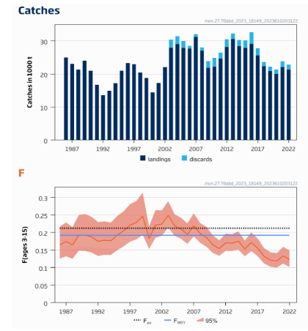
Figure 1. Long-term catches for White Anglerfish in Subarea 7 and Divisions 8.a-b and 8.d. Discards observations are available since 2003. Source: ICES 2023.
Therefore, the fishery removals of the stock, including the fishery under assessment, are included in the stock assessment process; it PASSES Clause C1.1
C1.2 The species is considered, in its most recent stock assessment, to have a biomass above the limit reference point (or proxy), OR removals by the fishery under assessment are considered by scientific authorities to be negligible.
According to CITES (2023), the spawning-stock biomass (SSB) and its 95% confidence intervals are above MSY B_{trigger}, B_{pa}, and B_{lim} (Figure 2).
Whereas:
MSY Btrigger = A biomass reference point that triggers a cautious response within the ICES Maximum Sustainable Yield -MSY framework;
FMSY = Fishing mortality consistent with achieving MSY;
B_{pa} = Precautionary reference point for spawning stock biomass;
B_{lim} = Limit reference point for spawning stock biomass.

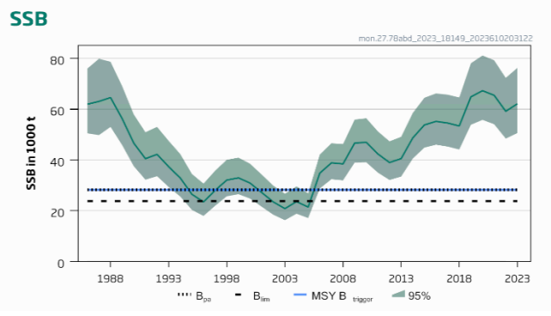
Figure 2. Long-term spawning stock biomass (SSB) trends in Subarea 7 and divisions 8.a-b and 8.d, with 95% confidence intervals. Source: ICES 2023.

Therefore, the stock is considered, in its most recent stock assessment, to have biomass above the limit reference point. The stock passes Clause C1.2.
References
ICES. 2023. White anglerfish (Lophius piscatorius) in Subarea 7 and divisions 8.a–b and 8.d (Celtic Seas, Bay of Biscay). In Report of the ICES Advisory Committee, 2023. ICES Advice 2023, mon.27.78abd, https://doi.org/10.17895/ices.advice.21840948
Links
MarinTrust Standard clause |  |  |  | 1.3.2.2
FAO CCRF |  |  |  | 7.5.3
GSSI |  |  |  | D.3.04, D5.01

https://www.iucnredlist.org/
https://cites.org/eng/app/appendices.php

