

MarinTrust Standard V2

By-product Fishery Assessment
DNK18 - Saithe (Pollachius virens)
in FAO 27, ICES 5.a (Iceland grounds)

MarinTrust Programme
Unit C, Printworks
22 Amelia Street
London
SE17 3BZ
E: standards@marin-trust.com
T: +44 2039 780 819

Table 1 Application details and summary of the assessment outcome
Fishery Under Assessment | Species: | Saithe (Pollachius virens)
 | Geographical area: | FAO 27, ICES 5.a (Iceland grounds)
 | Country of origin of the product: | Denmark  Flag countries: Iceland
 | Stock: | Saithe (Pollachius virens) in Division 5.a (Iceland grounds)
Date | April 2024
Report Code | DNK18
Assessor | Ana Elisa Almeida Ayres
Country of origin of the product - PASS | Denmark  Flag countries: Iceland
Country of origin of the product - FAIL | N/A

Application details and summary of the assessment outcome
Company Name(s): | FF Skagen A/S, Thyborøn
Country: | Denmark |  |  | Flag countries: | Iceland
Email address: |  |  | Applicant Code:

Certification Body Details
Name of Certification Body: |  |  | NSF / Global Trust Certification Ltd.
Assessor |  | Peer Reviewer | Assessment Days |  | Initial/Surveillance/Re-approval
Ana Elisa Almeida Ayres |  | Léa Lebechnech | 0.5 |  | Surveillance 2
Assessment Period |  | April 2024 – April 2025

Scope Details
Main Species | Saithe (Pollachius virens)
Stock | Saithe (Pollachius virens) in Division 5.a (Iceland grounds)
Fishery Location | FAO 27 - Division 5.a (Iceland grounds)
Management Authority (Country/ State) | European Union Common Fisheries Policy, Danish Directorate of  Fisheries (Fiskeristyrelsen), Icelandic Ministry of Industries and Innovation
Gear Type(s) | Bottom trawls, gillnets, others

Outcome of Assessment
Peer Review Evaluation | Agree with the assessor’s determination
Recommendation | APPROVED

Table 2. Assessment Determination
Assessment Determination
If any species is categorised as Endangered or Critically Endangered on Union for Conservation of Nature's Red List of Threatened Species - IUCN’s Red List, or if it appears in the Convention on International Trade in Endangered Species of Wild Fauna and Flora - CITES appendices, it cannot be approved for use as MarinTrust raw material. Saithe (Pollachius virens) is not categorised as Endangered or Critically Endangered on IUCN’s Red List and does not appear in CITES appendices; therefore, saithe (Pollachius virens) is eligible for approval for use as Marin Trust by-product raw material.
There is a species-specific management regime in place for this stock including a stock assessment with reference points defined, thus the stock was assessed under Category C. In the last stock assessment, removals are considered and the stock is above its limit reference point Blim, therefore the stock PASSES clauses C1.1 and C1.2.
Therefore, saithe (Pollachius virens) in FAO 27, Division 5.a (Iceland grounds) is APPROVED for the production of fishmeal and fish oil under the current MarinTrust v2.3 by-products standard.
Fishery Assessment Peer Review Comments
The assessor correctly classified saithe (Pollachius virens) in FAO 27, ICES Division 5.a (Iceland grounds) as Category C, the stock is subject to a specific management regime and reference points are defined.
Fishery removals are considered in the stock assessment process and the most recent stock assessment shows that the stock is above limit reference point. Therefore, the stock is considered to satisfy C1.1. and C1.2.
In conclusion, saithe in FAO 27, ICES Division 5.a (Iceland grounds) passes both clauses (C1.1 and C1.2) and therefore should be approved under the MarinTrust Standard v2.3.
Notes for On-site Auditor
N/A

Species Categorisation
NB: If any species is categorised as Endangered or Critically Endangered on the IUCN Red List, or if it appears in CITES Appendix 1, it cannot be approved for use as an MarinTrust raw material.

IUCN Red list Category
By-product material from a species listed by IUCN (the International Union for Conservation of Nature) under the Red List for the following categories shall immediately fail the assessment;

- EXTINCT (E) AND EXTINCT IN THE WILD (EW)
- CRITICALLY ENDANGERED (CR) facing an extremely high risk of extinction in the wild.
- ENDANGERED (EN) facing a very high risk of extinction in the wild.

By-product material may be used from the following categories provided that all clauses in the MarinTrust standard are passed.
- VULNERABLE (VU) facing a high risk of extinction in the wild.

- NEAR THREATENED (NT) does not qualify for above now, but is close or is likely to qualify for, a threatened category in the near future.
- LEAST CONCERN (LC) Widespread and abundant.
- DATA DEFICIENT (DD) and NOT EVALUATED (NE)

Table 3 Species Categorisation Table
Common name | Latin name | Stock | Management | Category | IUCN Red List Category | CITES Appendix 1
Saithe | Pollachius  virens | Saithe (Pollachius virens) in Division 5.a (Iceland grounds) | Yes | C | LC | No

CATEGORY C SPECIES

In a by-product assessment, Category C species are those which are subject to a species-specific management regime and are usually targeted species in fisheries for human consumption.
Clause C1 should be completed for each Category C species. If there are no Category C species in the fishery under assessment, this section can be deleted. Where a species fails this Clause, it should be assessed as a Category D species instead.

Species Name |  |  | Saithe (Pollachius virens)
C1 | Category C Stock Status - Minimum Requirements
 | C1.1 | Fishery removals of the species in the fishery under assessment are included in the stock assessment process, OR are considered by scientific authorities to be negligible. |  |  | Pass
 | C1.2 | The species is considered, in its most recent stock assessment, to have a biomass above the limit reference point (or proxy), OR removals by the fishery under assessment are considered by scientific authorities to be negligible. |  |  | Pass
Clause outcome: |  |  |  |  |  | PASS
C1.1 Fishery removals of the species in the fishery under assessment are included in the stock assessment process, OR are considered by scientific authorities to be negligible.
ICES advises that when the Icelandic management plan is applied, catches in the fishing year 2023/2024 should be no more than 66, 533 tonnes (ICES, 2023). The assessment type is a Separable statistical catch-at-age model (Muppet), with changes in selectivity for three different time periods, using catches in the model and in the forecast. Input data include Catch-at-age and age-disaggregated abundance indices from the Icelandic bottom-trawl survey -Spring (IS-SMB [G-3239]). Discarding is considered negligible.
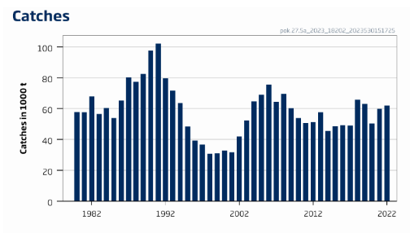
Figure 1. Saithe catches in Division 5.a (Iceland grounds) [ICES 2023].

Fishery removals of the species in the fishery under assessment are included in the stock assessment process. C.1.1 is met.

C1.2 The species is considered, in its most recent stock assessment, to have a biomass above the limit reference point (or proxy), OR removals by the fishery under assessment are considered by scientific authorities to be negligible.
Fishing pressure on this stock is above HR_{MSY} but below HR_{pa} and HR_{lim}; spawning-stock size is above MSY B_{trigger}, B_{pa}, and B_{lim}.
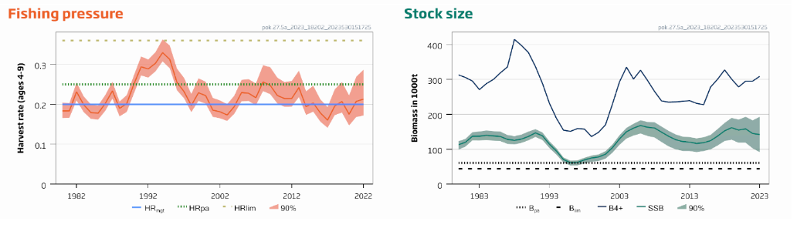
Figure 2. Spawning stock biomass for saithe in Division 5.a (Iceland grounds) [ICES 2023].

The species is considered, in its most recent stock assessment, to have a biomass above the limit reference point. C.1.2 is met.
References
ICES. 2023. Saithe (Pollachius virens) in Division 5.a (Iceland grounds). In Report of the ICES
Advisory Committee, 2023. ICES Advice 2023, pok.27.5a, https://doi.org/10.17895/ices.advice.21828393 (Published 9 June 2023).
Links
MarinTrust Standard clause |  |  |  | 1.3.2.2
FAO CCRF |  |  |  | 7.5.3
GSSI |  |  |  | D.3.04, D5.01

https://www.iucnredlist.org/
https://cites.org/eng/app/appendices.php
https://www.iucnredlist.org/species/190304/45098360

