DATED 20[ ]

Marine Ingredients Certifications Limited

and

Insert Name of User

MarinTrust Certification - Licence Agreement

THIS AGREEMENT is made the Insert date day of 20[Insert year]

Between
              - Marine Ingredients Certifications Limited a limited company incorporated and registered in England and Wales (company number 09357209) whose registered office is at Unit C Printworks, 22 Amelia Street, London SE17 3BZ (‘MarinTrust’); and
              - [Insert name of organisation], a [Insert entity type e.g. company limited by guarantee / shares] whose registered office is at [insert address] (registered company number [insert number]) (‘the User’).

Background
              - The User has successfully completed the MarinTrust Certification Process;
              - MarinTrust wishes to license the User use of the MarinTrust Branding in relation to any Certified Plants; and
              - The User agrees to make the MarinTrust Statement and comply with the Claims Policy in accordance with the terms of this Agreement.

The Parties agree as follows:

- Interpretation
 | ‘Agreement Date’ | The date of this Agreement appearing in its heading, or otherwise the date of signature;
 | “Certification Bodies” | The bodies appointed by MarinTrust to audit, assess and monitor compliance with the MarinTrust Programme and use of the MarinTrust Branding;
 | “Certified Sites” | Means the User’s sites that are certified under the MarinTrust Programme and which are listed at Schedule 5;
 | ‘Conflicting Brand’ | Any name, logo or other element which is confusingly similar to the MarinTrust Branding;
 | “End Date” | The date of expiry of the MarinTrust Certificate
 | ‘Licence Fees’ | the fees payable by the User to MarinTrust as set out in Schedule 6 and as may be amended by MarinTrust from time to time;
 | ‘MarinTrust Branding’ | The name/s and logo/s listed in Schedule 1;
 | ‘MarinTrust Brand Guidelines’ | The brand guidelines of MarinTrust, as set out in Schedule 2 and as may be updated and/or amended by MarinTrust from time to time;
 | “MarinTrust Certificate” | The certificate issued to the User by an approved Certification Body on behalf of MarinTrust on completion of the MarinTrust Certification Process and which sets out the elements of the User’s business that are certified under the MarinTrust Programme.
 | ‘MarinTrust Certification Process’ | The certification process carried out by MarinTrust and the relevant Certification Body in order to assess the User’s compliance with the MarinTrust Programme in accordance with the Standard Criteria, as outlined at: for the MarinTrust Standard and for the MarinTrust Chain of Custody Standard;
 | ‘MarinTrust Claims Policy’ | The policy which sets out how the User is permitted to use the MarinTrust Branding, a copy of which is set out in Schedule 3 and which may be updated and amended by MarinTrust from time to time;
 | ‘MarinTrust Programme” | The MarinTrust Programme consists of the following;  - The MarinTrust Standard;  - The MarinTrust Chain of Custody Standard; and  - Improver Programme
 | “MarinTrust Statement” | A statement that accurately describes the User’s certification under the MarinTrust Programme, examples of which are included at Schedule 4;
 | ‘Standard Criteria’ | The criteria by which MarinTrust (using the services of the Certification Bodies) assess compliance with the MarinTrust Programme, as outlined at:  - for the MarinTrust Standard  - for the MarinTrust Chain of Custody Standard;  and as may be updated by MarinTrust from time to time by giving reasonable notice in writing to the User;
 | ‘Term’ | The term specified under clause 4 below; and
 | ‘Territory’ | Worldwide

- Licence and Approval Process
  - In consideration for the User’s adherence to its obligations under this Agreement, and payment of the Licence Fees in accordance with clause 6.1.1, MarinTrust grants the User a non-exclusive non-transferable licence to use the MarinTrust Branding in the Territory for the Term in order to denote that the User complies with the MarinTrust Programme (and for no other purpose), provided such use is in accordance with this Agreement.
  - The User shall only be permitted to use the MarinTrust Branding in connection with the Certified Sites and the elements of the User’s business that are certified under the MarinTrust Program, as set out in the User’s MarinTrust Certificate.
  - The User must obtain, and procure that its employees and agents obtain, the prior written approval of MarinTrust to all materials (including but not limited to printed materials, digital materials and packaging materials) using the MarinTrust Branding, in accordance with the following approval process:
    - Prior to each use of the MarinTrust Branding (including use in printed materials, digital materials and packaging) the User must submit the proposed use (including copies of any relevant artwork and/or designs) to the following MarinTrust email address (or such alternative address that MarinTrust provides to the User) for approval – standards@marin-trust.com
    - MarinTrust shall take reasonable steps to review the proposed use within a reasonable time; and
    - Only once the proposed use has been approved in writing by MarinTrust shall the User be permitted to use the MarinTrust Branding in accordance with the written approval.
  - MarinTrust shall keep a record of the approvals granted under clause 2.3 and the User agrees to provide MarinTrust (and/or its agents, including a Certification Body) with such information as MarinTrust may reasonably require to check the User’s compliance with the approvals granted under clause 2.3.
- Certification Claim
  - The User shall comply with the relevant sections of the MarinTrust Claims Policy.
  - Whenever the User represents that it or any of its plants or products are certified under the MarinTrust Programme, the User shall ensure that it uses a MarinTrust Statement as set out in Schedule 4, or such alternative wording that is agreed in advance by MarinTrust.
- Term

The Agreement lasts for a period beginning with the Agreement Date and up until the End Date, unless terminated in accordance with clause 12 of this Agreement.
- MarinTrust’s Obligations
  - MarinTrust undertakes to use its reasonable endeavours during the Term to protect any and all intellectual property in the MarinTrust Branding.
  - Following completion of this Agreement, MarinTrust shall provide the User with a high resolution copy of the MarinTrust Branding.
  - MarinTrust warrants that it owns the copyright in the MarinTrust Branding. MarinTrust gives no warranty that use of the MarinTrust Branding does not infringe the rights of any third party. The User acknowledges that use of the MarinTrust Branding is at its own risk.
- User’s Obligations
  - The User shall:
    - Pay the Licence Fees to MarinTrust in accordance with Schedule 6;
    - not use the MarinTrust Branding or any Conflicting Brand other than as authorised by this Agreement;
    - not do anything which does or may damage MarinTrust, the MarinTrust Programme, the MarinTrust Branding, or the reputation or goodwill attaching to any of them;
    - comply with the MarinTrust Brand Guidelines; and
  - The User shall not use the MarinTrust Branding unless the User continues to hold a valid MarinTrust or MarinTrust CoC Certificate and its practices comply with the MarinTrust Programme in accordance with the Standard Criteria.
  - The User shall not use the MarinTrust Branding in any manner which MarinTrust may reasonably consider to be misleading (at its sole discretion).This includes but is not limited to:
    - use which conveys or implies that the MarinTrust Branding or any Conflicting Brand is a trade mark or a badge of origin in respect of the User or its products; and
    - use in any manner which may suggest that MarinTrust endorses the User or any other party, product or service.
  - During or after the Term, the User shall not, and shall not permit, encourage nor induce any other person, to:

5.4.1 in any part of the world use, attempt to register as a trade mark, or otherwise claim rights in the MarinTrust Branding or any Conflicting Brand, other than as authorised by this Agreement;
    - do or state anything, or make any omission (or encourage or induce another to do the same) that may lead to the MarinTrust Branding being removed from any trade marks register; or
    - do or state anything, or make any omission, which may convey that it has any right, title or interest in or to the ownership of any intellectual property in the MarinTrust Branding or any Conflicting Brand except under the terms of this Agreement.
  - The User shall not issue or publish any press release or public announcements in relation to the MarinTrust Programme and/or its completion of the MarinTrust Certification Process without MarinTrust’s prior approval via c
  - The User shall at any time during the Term and upon MarinTrust’s reasonable request promptly provide to MarinTrust (and/or any agent or party it appoints, including a Certification Body) such further evidence and information as MarinTrust may require in order to verify that the User is acting in compliance with this Agreement, the User continues to hold a valid MarinTrust Certificate and its practices comply with the MarinTrust Programme in accordance with the Standard Criteria.
  - The User acknowledges that certification under the MarinTrust Programme does not imply adherence or compliance with local or national regulations in the User’s country of origin or production, and that it is the responsibility of the User to ensure that it acts in accordance with all laws and regulations that apply to its business.
- Protection of the MarinTrust Branding
  - MarinTrust shall use its reasonable endeavours to promote the MarinTrust Programme and the MarinTrust Branding.
  - MarinTrust may identify the User in publicity and advertising materials for the purposes of advertising and promoting the MarinTrust Programme. MarinTrust will not publish personal data relating to the User and MarinTrust will process all personal data in accordance with its privacy policy, a copy of which is available here: [https://www.marin-trust.com/iffo-rs-ltd-privacy-policy].
- User’s warranties and indemnities
  - The User warrants that it has carried out the MarinTrust Certification Process diligently and accurately, and that the User and its practices comply with the MarinTrust Programme in accordance with the Standard Criteria.
  - The User recognises that any use of the MarinTrust Branding at any time when it or any of its practices do not meet the requirements of the MarinTrust Programme in accordance with the Standard Criteria shall constitute a breach of this Agreement.
  - The User indemnifies MarinTrust against any losses (including direct, indirect, special and consequential losses) incurred by MarinTrust as a result of a breach of this Agreement by the User, the User’s use of the MarinTrust Branding or its association with MarinTrust and/or the MarinTrust Programme, however caused.
- Assigning and Sub-Licensing
  - MarinTrust may transfer any of its rights or delegate any of its duties under this Agreement.
  - The User shall not transfer, license, sub-license, assign or otherwise part with possession of the benefit or burden of this Agreement without the prior written consent of MarinTrust, which MarinTrust may grant or withhold at its absolute discretion.
- Protection of the MarinTrust Branding
  - Use by the User of the MarinTrust Branding shall not operate to transfer to the User any right in respect of the MarinTrust Branding. The User acknowledges that all rights in the MarinTrust Branding including any goodwill associated with it belong to and shall remain vested in MarinTrust.
  - If the User becomes aware of any unauthorised use of, or of any infringement of any intellectual property in, the MarinTrust Branding, or of any claims or actions in connection with the MarinTrust Branding, it shall promptly notify MarinTrust with full details.
  - The User may not bring, defend or settle any action in relation to the MarinTrust Branding. MarinTrust may in its sole discretion bring or defend an action but shall not be obliged to bring or defend any proceedings.
- Confidentiality
  - Each party acknowledges that all information received by it from the other party in connection with this Agreement is of a confidential nature and has or will have been communicated to it in the strictest confidence on terms requiring it not to divulge or permit such information to be divulged to third parties other than to a party’s professional advisers or as may be required by law, nor to permit such information to be used by third parties and not to use such information so as to gain unfair advantage over or compete with the other party at any time whether before or after the expiry of this Agreement and each party warrants and undertakes with the other party that it shall not do or omit to do anything which might result in a breach of such terms.
  - This clause 11shall not extend to information which was already in the lawful possession of a party prior to the commencement of the MarinTrust Certification Process or which is already public knowledge or becomes so subsequently (other than as a result of a breach of this clause).
  - This clause 11 shall not prevent MarinTrust from publishing and/or sharing anonymous information on production levels and activity for annual reporting, auditing and statistical purposes.
  - Notwithstanding clause 11.1, MarinTrust may, with the User’s prior written consent, publicly disclose such information that may otherwise be confidential as may be reasonably necessary to demonstrate to the general public that the User is certified under the MarinTrust Programme and complies with the MarinTrust Programme in accordance with the Standard Criteria. In particular, the User hereby consents to MarinTrust publishing a copy of the User’s MarinTrust Certificate and any other certificate of certification for Certified Sites on the MarinTrust’s website.
- Termination
  - This Agreement shall automatically terminate with immediate effect in the event that:
    - the User no longer holds a valid MarinTrust Certificate;
    - the User is no longer certified under the MarinTrust Programme, for any reason; and/or
    - any of the User’s practices no longer comply with the MarinTrust Programme in accordance with the Standard Criteria.
  - MarinTrust may terminate this Agreement with immediate effect by giving written notice to the User if the User:
    - does anything which in MarinTrust’s reasonable opinion brings, or is reasonably likely to bring MarinTrust, the MarinTrust Programme or the MarinTrust Branding into disrepute;
    - uses the MarinTrust Branding or any Conflicting Brand other than as is permitted by this Agreement;
    - repeatedly breaches any of the terms of this Agreement, or breaches any material term of this Agreement and, where the breach is remediable, MarinTrust has given the User 28 days’ written notice requiring it to remedy the breach and it has failed to do so in the 28 day period;
    - becomes insolvent, is adjudicated bankrupt, or compounds with, or makes any arrangement with, or makes a general assignment for the benefit of, its creditors;
    - compulsorily or voluntarily enters into liquidation, except for the purposes of a bona fide reconstruction or amalgamation;
    - has an administrator, receiver or manager appointed over the whole, or a substantial part, of its undertakings or assets; or
    - ceases or threatens to cease to carry on its business.
  - The User must promptly notify MarinTrust if it decides to stop using the MarinTrust Branding at any point during the Term. For the avoidance of doubt, where the User has decided to stop using the MarinTrust Branding but the User continues to be certified under the MarinTrust Programme, the User may continue to represent that it is certified under the MarinTrust Programme providing it continues to comply with the terms of this Agreement, including but not limited to making the MarinTrust Statement and complying with the MarinTrust Claims Policy.
  - If the User has stopped using the MarinTrust Branding in accordance with clause 12.3, it may resume its use of the MarinTrust Branding during the Term on providing MarinTrust with at least one month’s prior notice and providing that the User complies with the terms of this Agreement.
- Consequences of Termination

On termination of this Agreement the User will:
  - immediately cease to use and desist from using the MarinTrust Branding and/or any Conflicting Brand;
  - immediately cease to represent or suggest that any element of the User’s business is certified under the MarinTrust Programme and remove the MarinTrust Statement from all public facing materials; and
  - refrain from performing any act, or making any statement or omission, which conveys or implies that the User is authorised to use the MarinTrust Branding, or that the User or any of its practices comply with the MarinTrust Programme, or any of its practices are certified under the MarinTrust programme.
- Dispute resolution
  - If any dispute arises in connection with this Agreement, a director or other senior representatives of the parties with authority to settle the dispute will, within 21 days of a written request from one party to the other, meet in a good faith in an effort to resolve the dispute.
  - If the dispute is not wholly resolved at that meeting, the parties agree to enter into mediation to settle such a dispute and will do so in accordance with the CEDR Model Mediation Procedure. Unless otherwise agreed between the parties within 21 days of notice of the dispute, the mediator will be nominated by CEDR. To initiate the mediation a party must give notice in writing ('ADR notice') to the other party to the dispute, referring the dispute to mediation. A copy of the request should be sent to CEDR. Unless otherwise agreed, the mediation will start not later than 28 days after the date of the ADR notice.
  - No party may commence any court proceedings or arbitration in relation to any dispute arising out of this Agreement until it has attempted to settle the dispute by mediation and either the mediation has terminated or the other party has failed to participate in the mediation, provided that the right to issue proceedings is not prejudiced by a delay.
- Variation

This Agreement may only be amended in writing once signed by authorised representatives of MarinTrust and the User.
- Entire Agreement

This Agreement represents the entire agreement between the parties concerning the subject matter of this Agreement, and supersedes all prior agreements, arrangements, negotiations and/or understandings between the parties.
- Non-Waiver

No failure or delay on the part of either party to exercise any right or remedy under this Agreement shall be a waiver of such right or remedy.
- Severability

If any part of this Agreement is held to be invalid, amendments to this Agreement may be made by the addition or deletion of wording as appropriate to remove the invalid part but otherwise the remainder of this Agreement shall remain valid and enforceable to the maximum extent permissible under applicable law.
- Governing Law & Jurisdiction

This Agreement and its interpretation, construction and effect shall be governed by the laws of England and Wales and the parties submit to the exclusive jurisdiction of the courts of England and Wales.
- Exclusion of Third Party Rights

This Agreement does not create any right enforceable by any person who is not a party to it, except that a person who is the permitted successor to, or assignee of the rights of, a party to this Agreement is deemed to be a party to this Agreement and the rights of such successor or assignee shall, subject to and on any succession or assignment permitted by this Agreement, be regulated by the terms of this Agreement.
Schedule 1

The MarinTrust Branding

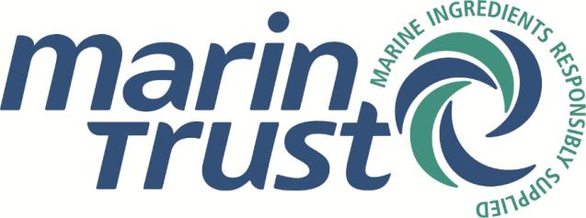

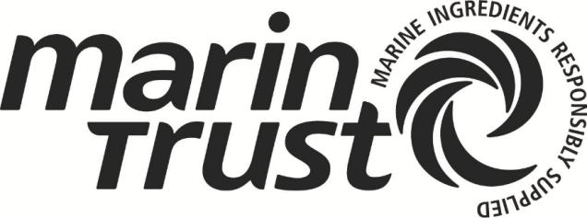

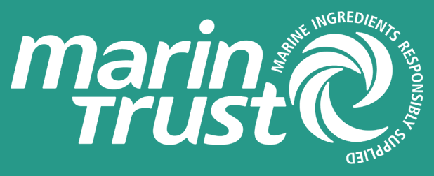
Schedule 2

MarinTrust Brand Guidelines

The MarinTrust Brand Guidelines can be found on the MarinTrust web page here and found directly via the following link.

MarinTrust, formerly known as MarinTrust, is the leading independent business to business certification programme for the production of marine ingredients consisting of:

- the MarinTrust for Responsible Supply,
- the MarinTrust Chain of Custody for Responsible Supply
- and the MarinTrust Improver Programme.

The logo can be placed over imagery but should always be perfectly legible and visible at all times.

Logo colours should be used accordingly.

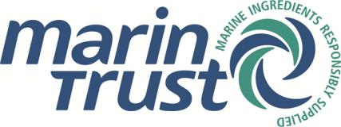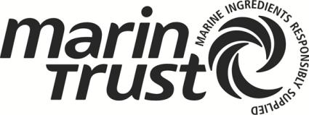

The MarinTrust logo must not be re-drawn or altered in any way. It must remain at its supplied proportions.
The logo in its entirety must always be visible.

Usage by Licencees

The two existing MarinTrust logo - RS Assured and RS Chain of Custody – are replaced with a single logo.

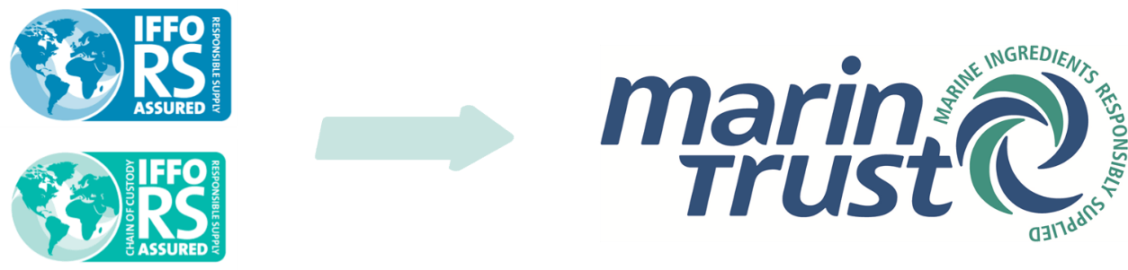

Accepted FIPs under the MarinTrust Improver Programme shall not use the MarinTrust logo.
Spelling

When used in plain text, MarinTrust spells without any space.

Both M (Marin) and T (Trust) have capital letters.

Schedule 3

MarinTrust Claims Policy

For Users certified under the MarinTrust Standard
- In using the MarinTrust Branding, the User shall:
  - only use the MarinTrust Branding in connection marine ingredient products (such as fishmeal and fish oil) that have be produced from plants that have been certified under the MarinTrust Programme and which appear in the list of certified fishmeal plants on the MarinTrust website (which may be changed and updated from time to time).
  - be permitted to use the MarinTrust Branding on packaging material and associated products providing that such products have come from factories that are certified under the MarinTrust Programme and that they use raw material that has been approved by MarinTrust;
  - be permitted to use the MarinTrust Branding on the premises of the User’s factory to demonstrate its compliance to the MarinTrust Programme, providing that the factory remains certified under the MarinTrust Programme
  - be permitted to display the MarinTrust Branding in non-production facilities (such as office headquarters) providing that such display does not give the impression that the company as a whole has been approved under the MarinTrust Programme
  - ensure that the MarinTrust Branding is not displayed in any production facilities that are not certified under the MarinTrust Programme;

For Users certified under the MarinTrust Chain of Custody Standard
- In using the MarinTrust Branding, the User shall:
  - only use the MarinTrust Branding in connection with the fishmeal and fish oil from certified fishmeal plants expressly identified in the Chain of Custody certificate issued to the User;
  - only use the MarinTrust Branding in connection with connection marine ingredient products (such as fishmeal and fish oil) from a certified plant only if its entire supply chain from the certified factory has received a Chain of Custody certificate;
  - not use the MarinTrust Branding in connection with combined or prepared products unless all the fishmeal or fish oil in such products is from a certified MarinTrust factory and is from a fully certified supply chain;
  - be permitted to use the MarinTrust Branding on packaging material and associated products providing that such products have come from factories that are certified under the MarinTrust Programme and that they use raw material that has been approved by MarinTrust;
  - be permitted to use the MarinTrust Branding on the premises of the User’s factory to demonstrate its compliance to the MarinTrust Programme, providing that the factory remains certified under the MarinTrust Programme
  - be permitted to display the MarinTrust Branding in non-production facilities (such as office headquarters) providing that such display does not give the impression that the company as a whole has been approved under the MarinTrust Programme
  - ensure that the MarinTrust Branding is not displayed in any production facilities that are not certified under the MarinTrust Programme;
Schedule 4

Example MarinTrust Statements

Example MarinTrust Statements where the User is certified under the MarinTrust Standard:
- [insert certified factory name] is a MarinTrust certified site/factory;
- [insert certified ingredient ie Fishmeal, Fish Oil] comes from a MarinTrust certified site/factory that has been independently certified to the MarinTrust standard for the responsible production of Marine Ingredients
- This [insert certified ingredient ie Fishmeal, Fish Oil] has met the MarinTrust standard for responsible supply of marine ingredients.

Example MarinTrust Statements where the User is certified under the MarinTrust Chain of Custody Standard
- [insert certified company name] is MarinTrust Chain of Custody certified
- [insert certified ingredient ie Fishmeal, Fish Oil] comes from a MarinTrust CoC certified company that has been independently certified to the MarinTrust Chain of Custody standard for the responsible supply of Marine Ingredients;

Example MarinTrust Statements where the User is accepted under the MarinTrust Improver Programme
Whilst those that are accepted onto the MarinTrust Improver Programme (MarinTrust IP) are not able to use the MarinTrust logo, they may sell products within the approved scope as MarinTrust Improver Programme material.

In order for a site to make an MarinTrust IP claim, a site must be listed in the MarinTrust Improver Programme Accepted Sites list on the MarinTrust website and they must also be listed as a stakeholder in an MarinTrust accepted Fishery Improvement Project (FIP) on the MarinTrust website. The species being used as a raw material for the MarinTrust IP claim must also be listed within the relevant FIP scope on the MarinTrust website.

- [insert accepted factory name] is a MarinTrust Improver Programme Accepted Site
- [insert approved ingredient ie Fishmeal, Fish Oil] comes from a MarinTrust Improver Programme Accepted site/factory that has been independently verified to meet the requirements of the Improver Programme
- This [insert approved ingredient ie Fishmeal, Fish Oil] is accepted, as part of the Fishery Improvement Programme (FIP) scope, under the MarinTrust Improver Programme
Schedule 5

Certified Sites
- The following User sites are certified under the MarinTrust Programme:
Name of Certified Sites | Address | Certificate Number

- Additional Certified Sites
  - MarinTrust may agree to admit additional sites as Certified Sites from time to time, subject to the User providing MarinTrust (and/or its agents, including a Certification Body) with such information as MarinTrust may require to determine that the site complies with the MarinTrust Programme.
  - Where MarinTrust agrees to add a site as a Certified Site, such site will only be deemed to be a Certified Site once an updated version of this schedule has been signed by an authorised representative of both parties.
- Removal of Certified Sites
  - A site will automatically cease to be Certified Site where:
    - The site is no longer certified under the MarinTrust Programme, for any reason; and/or
  - The practices at the site no longer comply with the MarinTrust Programme in accordance with the Standard Criteria
Schedule 6

Licence Fees

The User shall pay the following fees to MarinTrust:
- An annual fee of £250 per Certified Site;

All the above amounts are exclusive of VAT, to the extent that VAT is applicable.

MarinTrust may increase the Licence Fees from time to time and MarinTrust shall notify the User of any such increase.

MarinTrust will issue an invoice for the Licence Fees and all invoices must be paid by the User within 14 days of the invoice date.

Signed for and on behalf of

Marine Ingredients Certifications Limited
by:
Name: ……………………………….
Signature: ……………………………….
Job Title: ……………………………….
Date: ……………………………….

Signed for and on behalf of
[insert name of User]

by:
Name: ……………………………….
Signature: ……………………………….
Job Title: ……………………………….
Date: ……………………………….

The MarinTrust Improver Programme has its own Claims Agreement which can be found here [https://www.marin-trust.com/marintrust-logo-guidlines].

